Christmas Art Competition

You are invited to take part in our Christmas Art Competition.
This year the theme for the competition is
The Chronicles of Narnia - The Lion the Witch and the Wardrobe.

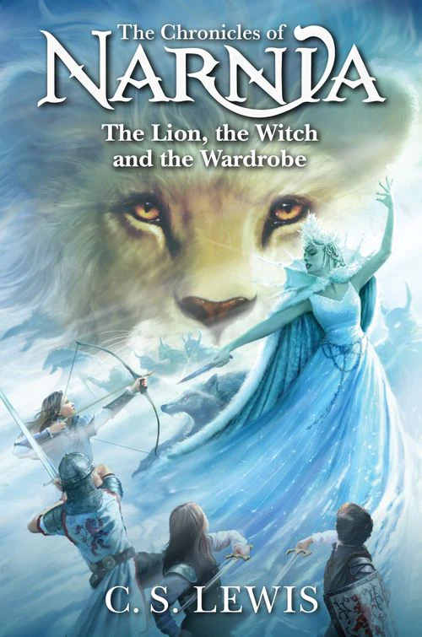

Following the theme above, pupils can make a Christmas decoration, create a piece of artwork, sew, collage, or bake. The list of possibilities is endless.

Closing date - Wednesday the 10th December.

Please ensure that any entries include the pupils’ name, class and house.
Please bring entries to Mrs Duerden in the Art Department so that we can display as many of them as possible.
House winners will be notified on the final day of term.



